**Advanced Software Engineering**

**Assignment 1**

By,

Surendra Koripella,

16143350.

**Class Diagram:**

Floor button and elevator button are the classes which share generalization relation.

Door is dependent on elevator control so, there is a dependency relation between them.

Elevator can be assumed as a part of elevator control so, there is association relation between them.

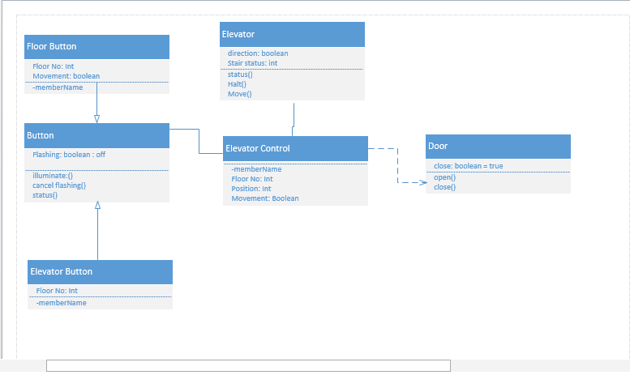

**Sequence Diagram:**

Step 1: Here the passenger firstly presses the floor button.

Step 2: Here it signifies by illuminating the lights.

Step 3: Controller generates the request to the elevator.

Step 4: Elevator generates command for the door to open the door.

Step 5: Door will be opened and closed after person enters.

Step 6: Elevator and controller request will be terminated once door closes.

Step 7: Controller sends request to turn off the button light.

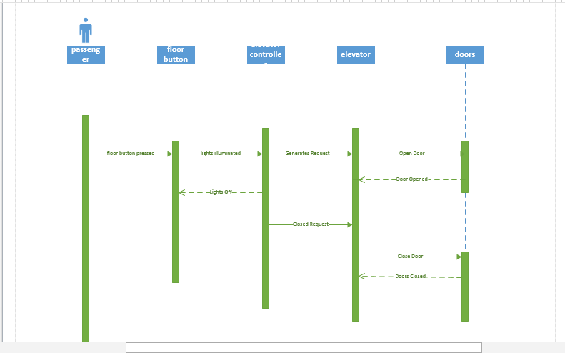

**Architecture Diagram:**

Here I assumed two cases

Case 1: There is a proximity sensor which detects person and automatically signifies the button for further process to occur.

Case 2: If in case the sensor fails then the person himseld/herself pushes the button and further process takes place as shown in the diagram.

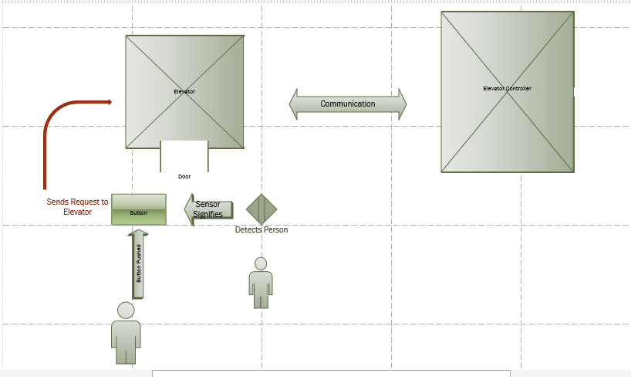

**ScrumDo**

The following slide is for sign up.

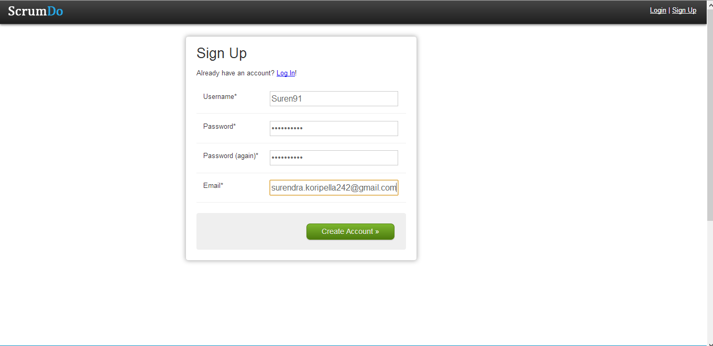

Creating an Organization and a Project.

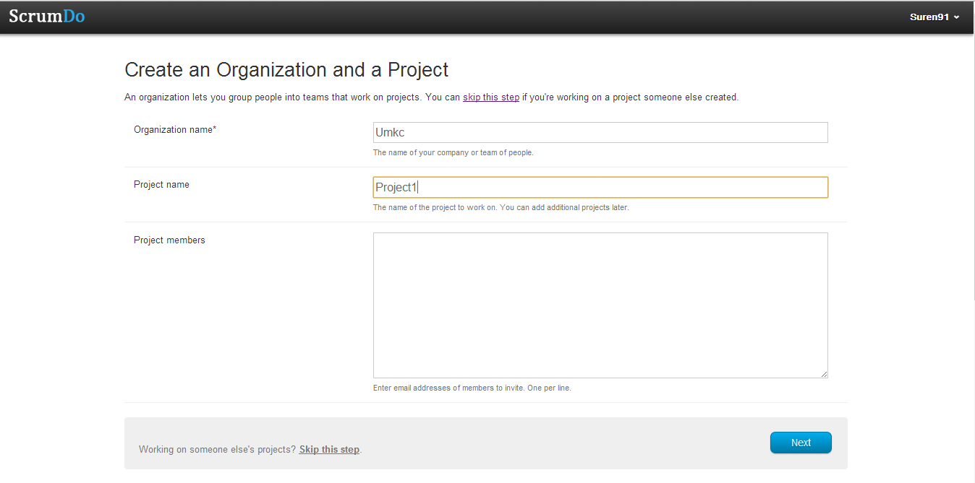

Story Creation:

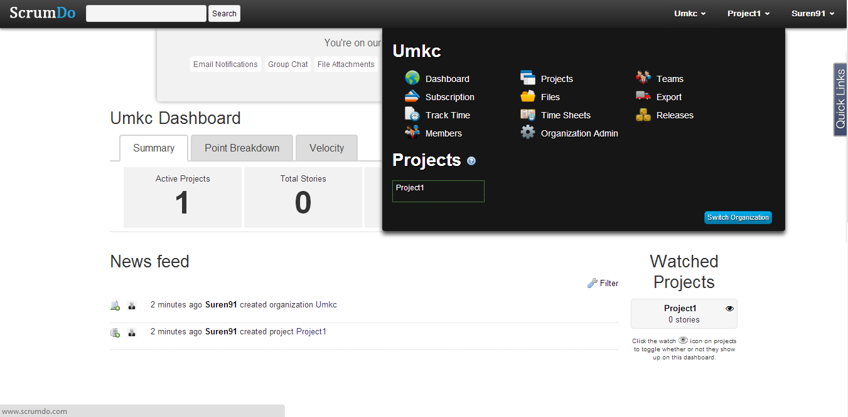

Backlog contains list of requirements that are maintained for a story created.

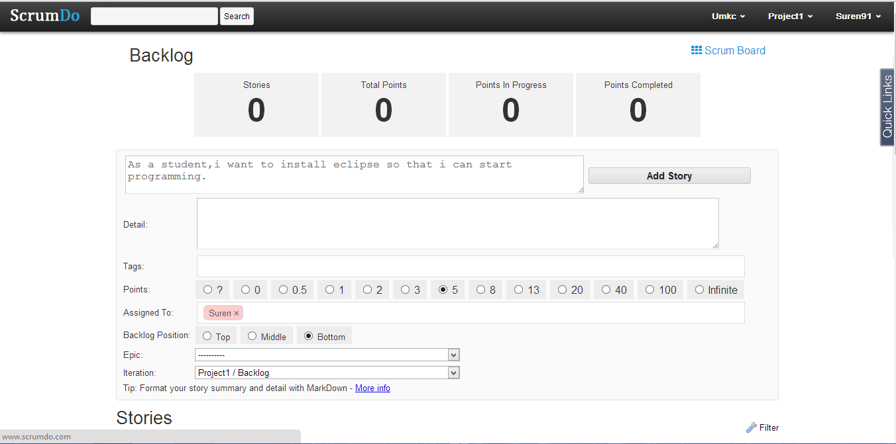

The below slide contains the backlog which contains the list of stories created.

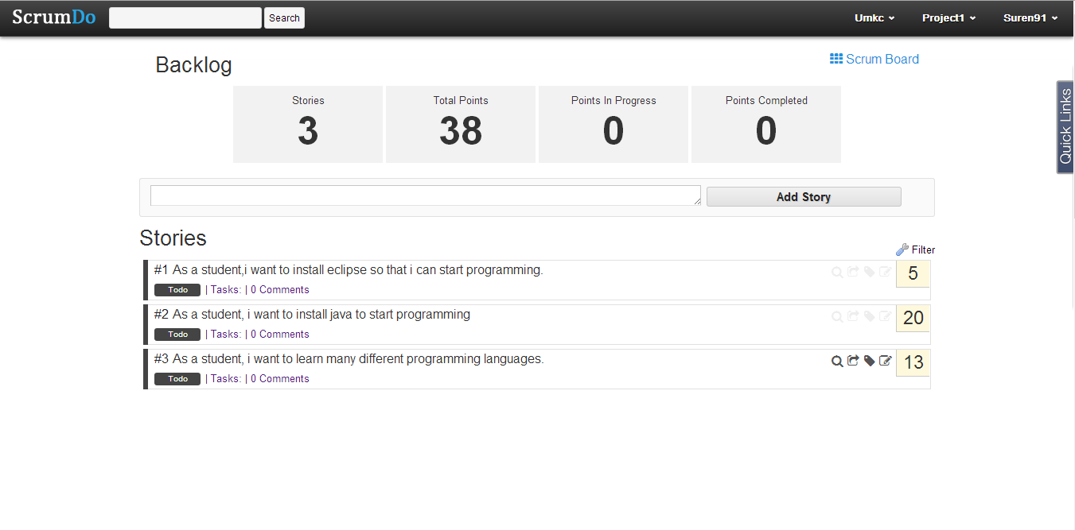

Iteration creation :

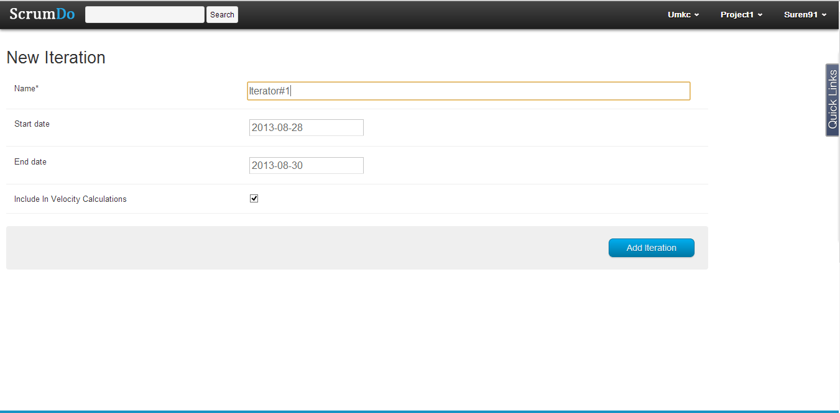

Iteration created can be seen as follows-

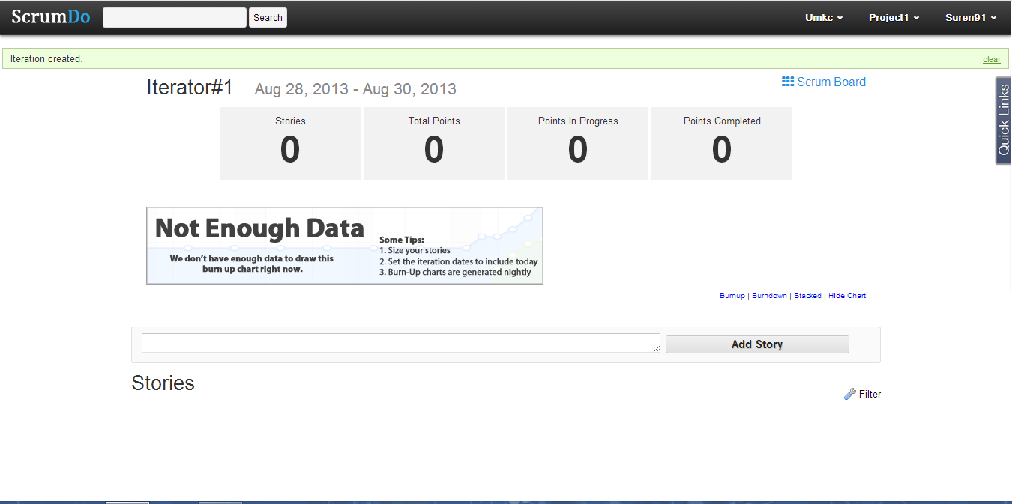

The below shows the iteration planning which is the process of moving the stories from one phase to another phase.

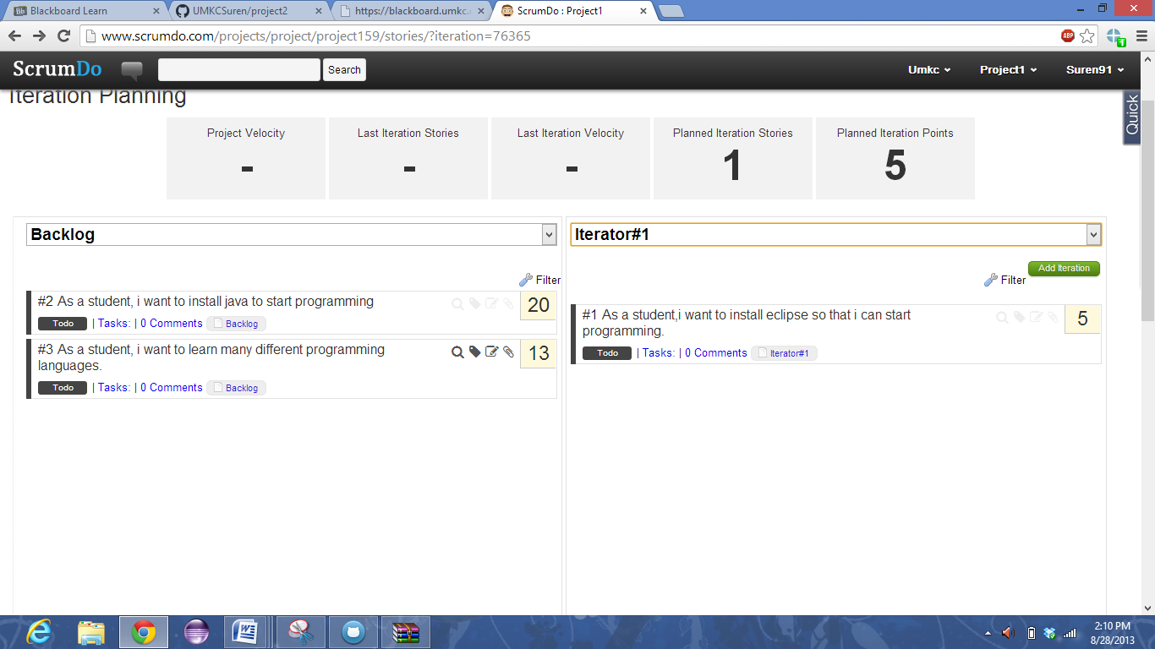

Epic Story Creation:

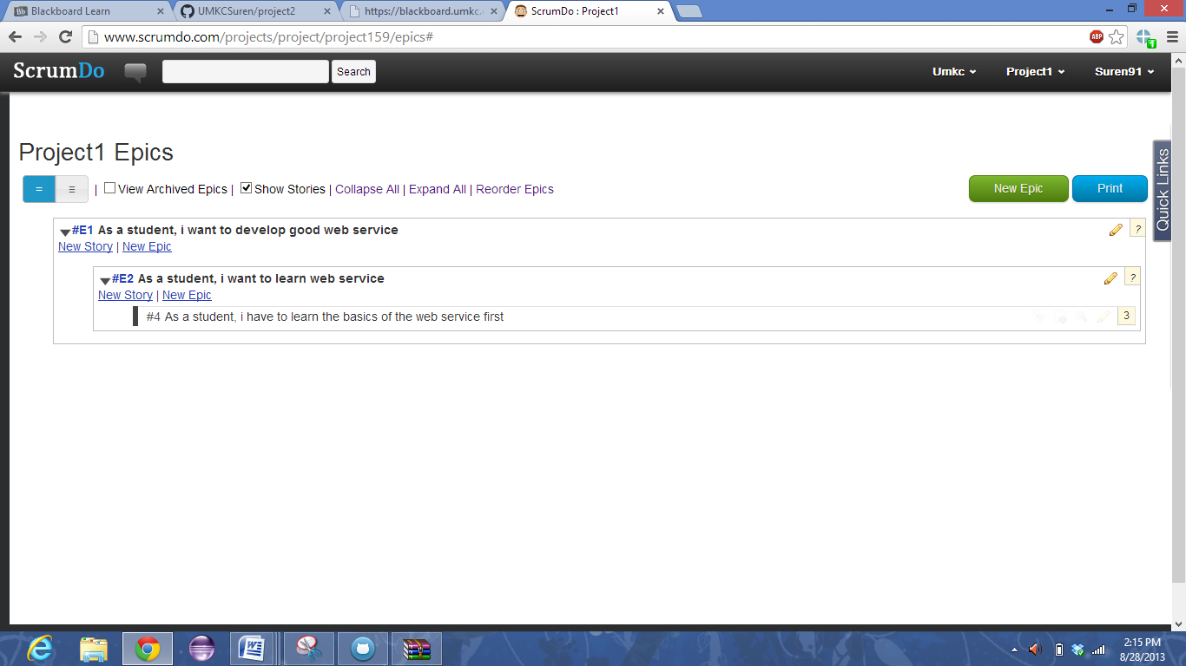

The below slide shows the Scrum Do which shows the list of stories present in the different phases.

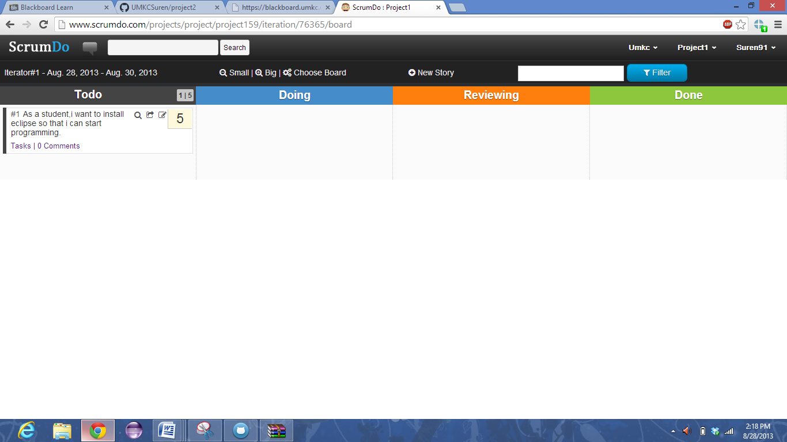

Team Creation:

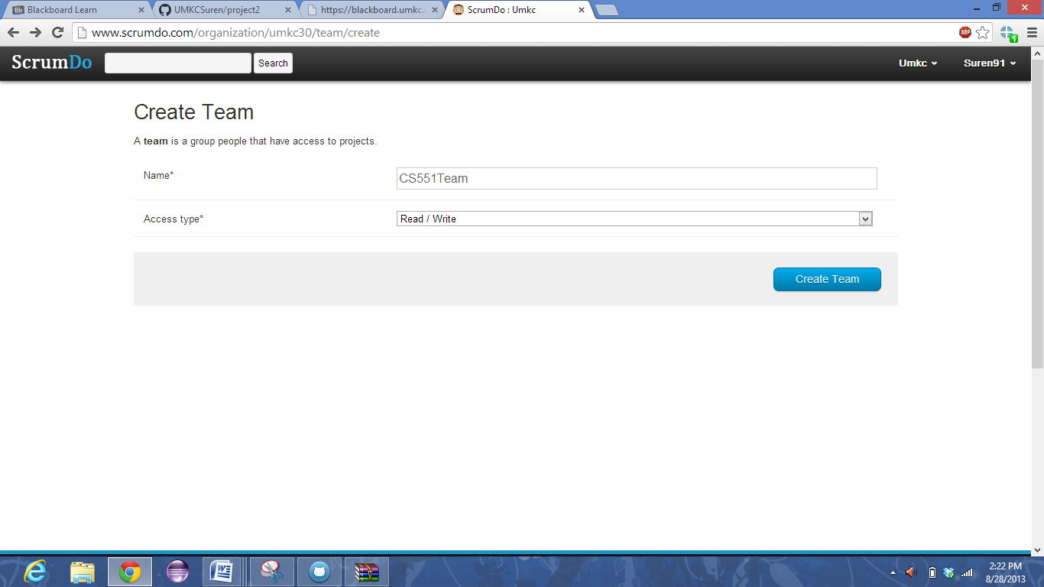

Sending requests to people to join the team:

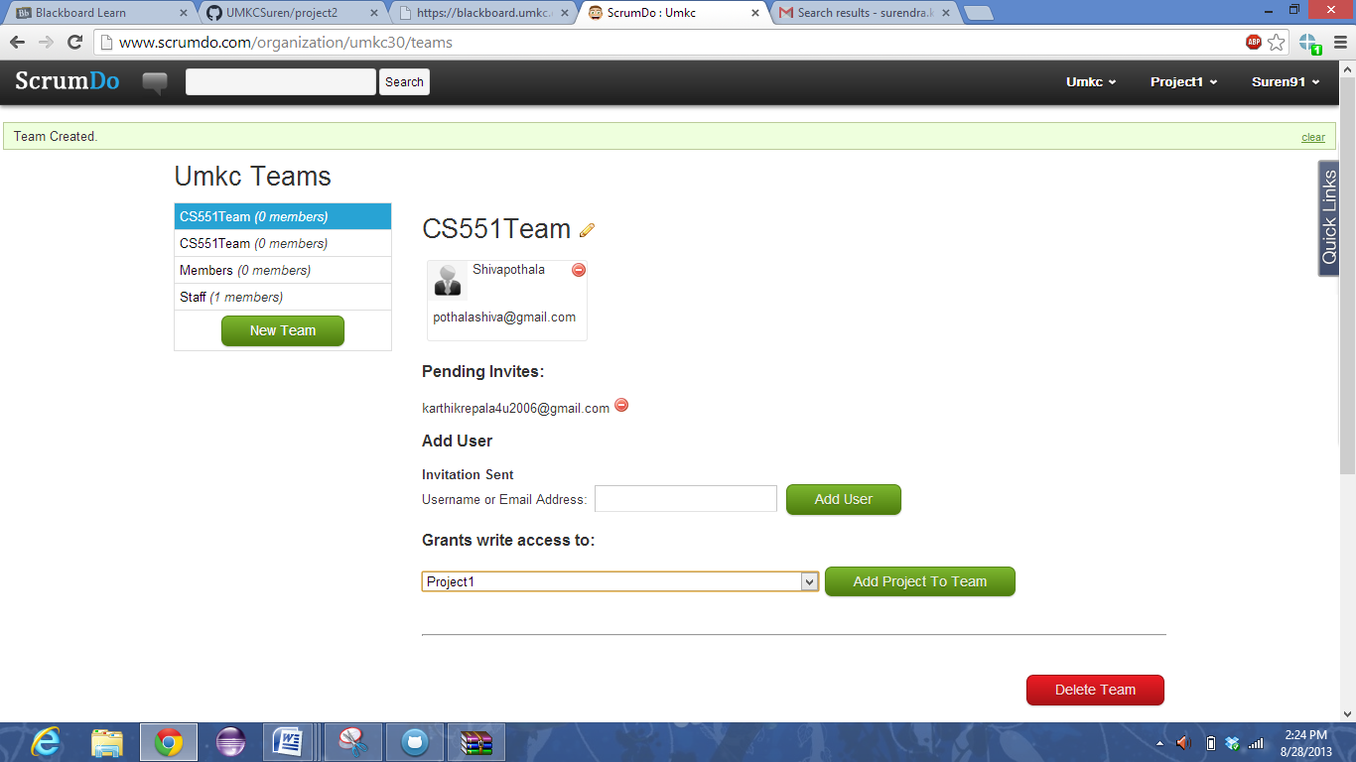

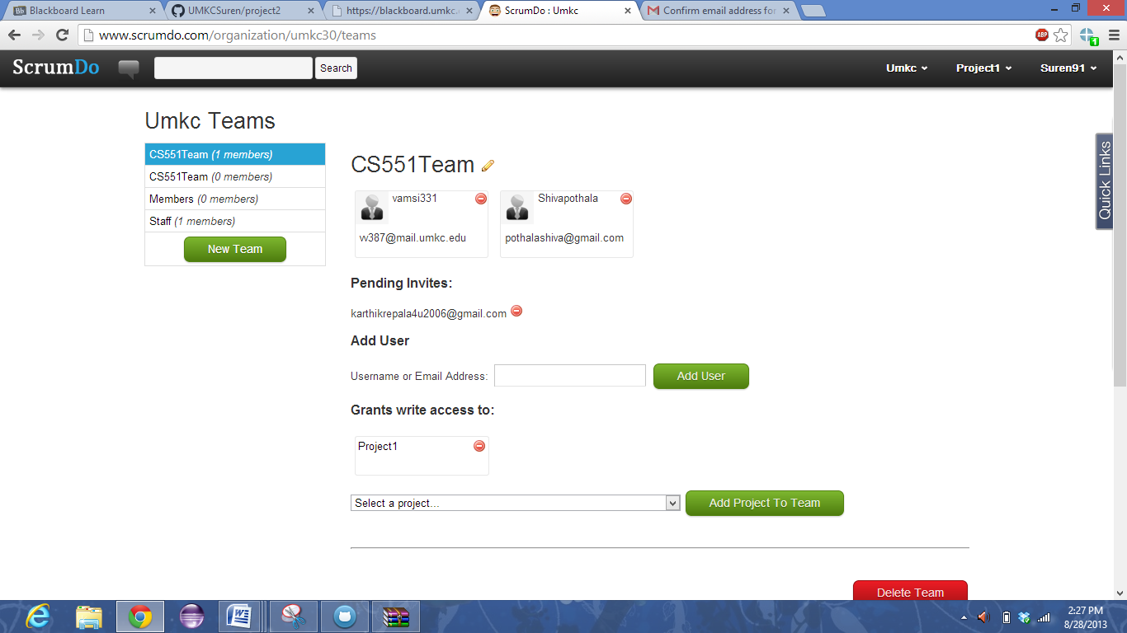

The Dashboard contains the summary of stories created and the activities performed by the user.

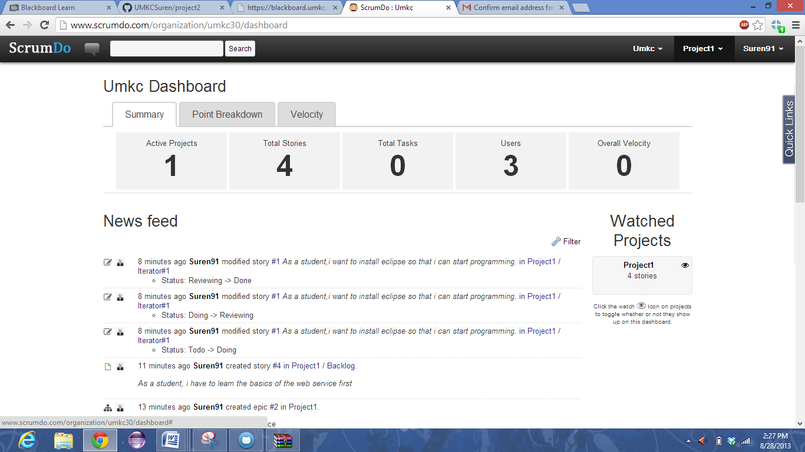

**Git Hub:**

